**THIS ASSEMBLY CONTAINS ESD SENSITIVE AND MSL 2 DEVICES.**

Cover

# Scope:

This test procedure provides information on control of S-Ku Integrated Microwave Filters (IMF**®**)series on 802931 carrier boards.

# Purpose:

Aid in setup and demonstration of the S-Ku IMF series.

# Equipment Table:

|  |  |
| --- | --- |
| **Equipment Description** | **QTY** |
| 802931 Assembly with filter attached | 1 |
| Integrated Filter Controller (IFC) | 1 |
| IFC to EEPROM board cable | 1 |
| EEPROM board to filter cable | 1 |
| EEPROM board | 1 |

Table 1: Required Test Equipment (OR EQUIVALENT).

# Test Requirements:

|  |  |
| --- | --- |
| Temperature: | -40°C, +25°C, +85°C |
| Humidity: | none |
| Vibration: | None |
| Altitude: | Normal Ground |

Table 2: Test Conditions.

# IMF Recommended Ratings

|  |  |  |  |  |
| --- | --- | --- | --- | --- |
| Parameter | Min. | Nom. | Max. | Notes |
| VCC | +3.0 V | +5 V | +10 V | DUT supply voltage |
| ICC | - | 0.3 mA | 2mA | DUT supply current |
| GPIO 1:12 | +3.0 V | +5 V | +10 V | Voltage for GPIO control |
| RF Pin (dBm) | - | +20 | +23 | RF Input power |

Table 3. Ratings.

# Pin numbers, ratings and descriptions

## 802931 Pinout

|  |  |  |  |
| --- | --- | --- | --- |
| Pin | Name | Operation for IMF1004-IMF1007 | Operation for IMF1003 |
| 1, 2 | V1 | NC | NC |
| 3 | V2 | NC | NC |
| 4 | V3 | NC | GPIO: 0 or VCC |
| 5 | V4 | NC | GPIO: 0 or VCC |
| 6 | V5 | VCC | GPIO: 0 or VCC |
| 7 | V6 | GPIO: 0 or VCC | GPIO: 0 or VCC |
| 8 | V7 | GPIO: 0 or VCC | GPIO: 0 or VCC |
| 9 | V8 | GPIO: 0 or VCC | GPIO: 0 or VCC |
| 10 | V9 | GPIO: 0 or VCC | VCC |
| 11 | GND | GND | GND |
| 12 | V10 | GPIO: 0 or VCC | GPIO: 0 or VCC |
| 13 | V11 | GPIO: 0 or VCC | GPIO: 0 or VCC |
| 14 | V12 | GPIO: 0 or VCC | GPIO: 0 or VCC |
| 15 | V13 | GPIO: 0 or VCC | GPIO: 0 or VCC |
| 16 | V14 | VCC | GPIO: 0 or VCC |
| 17 | V15 | NC | GPIO: 0 or VCC |
| 18 | V16 | NC | VCC |
| 19, 20 | NC | NC | NC |



Table 4. 802931 Board Pinout, Operation.

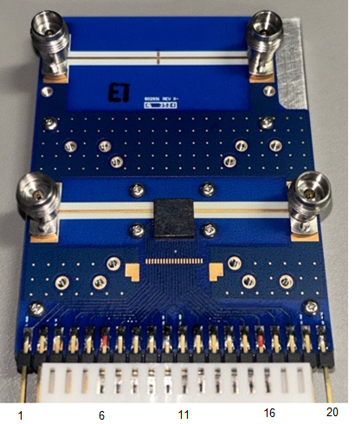

Figure 1. 802931.

# IFC Set Up

## Connecting the IFC Hardware

### IFC IO and Cables

#### IFC connections include: Power supply input, USB, & IFC IO to EEPROM board IO.

#### EEPROM board IO include: IFC IO to EEPROM board IO & EEPROM board to Filter IO.

### Plug in the IFC power cable, then plug in the USB cable from the computer to the IFC.

### Prior to connecting the IFC to the EEPROM board cable, verify the EEPROM to filter cable is connected as shown in Figure 2. Note the position of the connector on the 802931. Make sure the labels on the connectors are facing down towards the GND plane.

### If all is correct, connect the IFC to the EEPROM board cable.

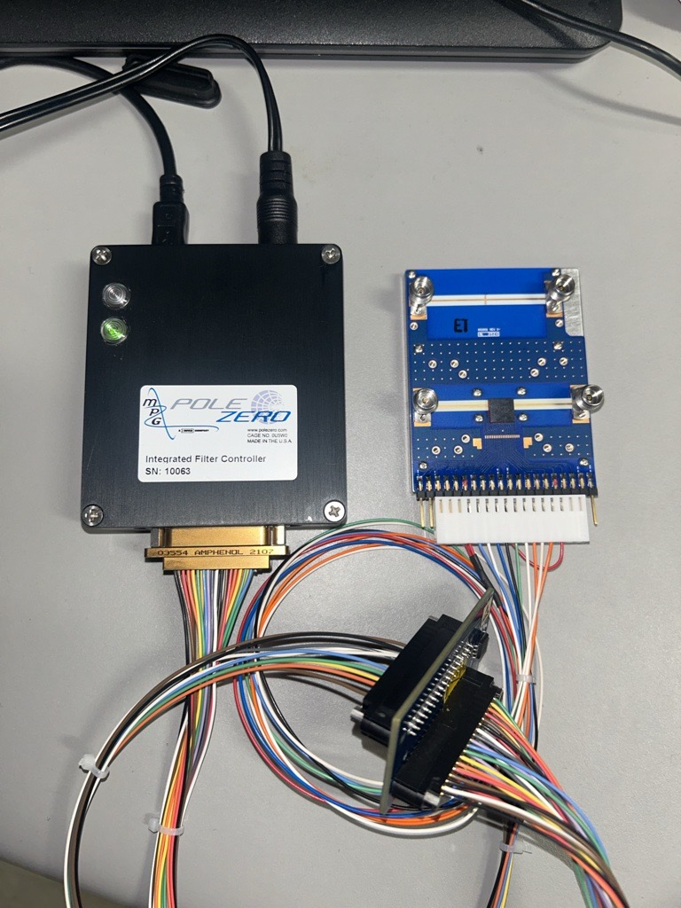

Figure 2. IFC Hardware setup.

## Controlling the filter using the IFC Software:

### Download & open 107417 Customer Demo Controller Software. (V1.3.0.0 or greater)

### Connect to the IFC: Under the Communication tab, Select “Auto” then “connect” in the dropdown menu under the communication tab to auto connect to the correct communication port.

### Set the IO voltage to the correct value:

#### Using VCC = 5.0V : I/O = 5.000V.

### Set all other parameters to desired values and apply ON state.

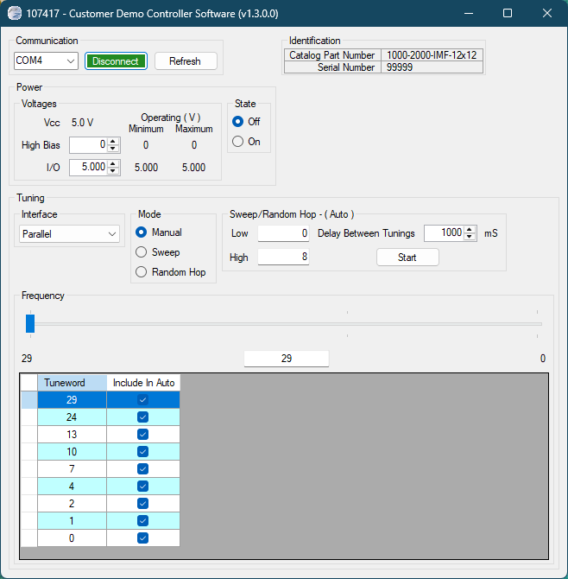

Figure 3. IFC Control Panel.

# generic setup and Manual oPERATION

## GPIO/Parallel Mode

### Ensure GND, VCC, all GPIO pins are properly connected to the power supply/controller. Floating the IO will cause the filter to malfunction. If using the IFC, see section 7.0.

### Set VCC and GPIO levels.

### There are 16 separate voltage pins on the 802931 evaluation board. By individually driving these lines with 0V or VCC , one can achieve full tuning for the filter on the board. For filters 4GHz and above, there are only 4 bits of tuning (8 total GPIO). Follow Table 4 and Figure 1 for specific operation of the Unit Under Test (UUT).

# Troubleshooting

## Red Light Reset

### If the red light on the IFC comes on as shown in the picture. The IFC will need to be reset.

### Reset the IFC by first unplugging the power chord and then the USB cable.

### Wait 1 minute and then plug them back in. Power supply first and then the USB cable.



Figure 6 - IFC Red Light