**THIS ASSEMBLY CONTAINS ESD SENSITIVE AND MSL 2 DEVICES.**

Cover

# Scope:

This test procedure provides information on control of Integrated Microwave Filters [IMF**®** (IMF-3000-5000-SXX, IMF-4000-6000-SXX)] series on ENG00257 carrier boards.

# Purpose:

Aid in setup and demonstration of the S-C IMF series.

# Equipment Table:

|  |  |
| --- | --- |
| **Equipment Description** | **QTY** |
| ENG00257 Assembly with filter attached | 1 |
| Integrated Filter Controller (IFC) | 1 |
| IFC to EEPROM board cable | 1 |
| EEPROM board to filter cable | 1 |
| EEPROM board | 1 |

Table 1: Required Test Equipment (OR EQUIVALENT).

# Test Requirements:

|  |  |
| --- | --- |
| Temperature: | -40°C, +25°C, +85°C |
| Humidity: | none |
| Vibration: | None |
| Altitude: | Normal Ground |

Table 2: Test Conditions.

# IMF Recommended Ratings

|  |  |  |  |  |
| --- | --- | --- | --- | --- |
| Parameter | Min. | Nom. | Max. | Notes |
| $$V_{SUPP}$$ | +3.0 V | 3.3 V | +3.6 V | +3.3V DUT supply voltage |
| $$I_{SUPP}$$ | - | 0.7 mA | 6mA | +3.3V DUT supply current |
| $$V_{RESET}$$ | 0 | +2.5 V | +3.3 V | RESET voltage |
| $$V_{DIGITAL}$$ | 0 V | +2.5 V | +3.3 V | Voltage for CLK, DATA, $\overline{STB}$ |
| GPIO 0:7 | 0 V | - | +3.3 V | GPIO/Parallel control voltage |
| RF Pin (dBm) | - | - | +25 | RF Input power |

Table 3. Ratings.

# Pin numbers, ratings and descriptions

## ENG00257 Pinout

|  |  |  |  |
| --- | --- | --- | --- |
| Expander Pin | Name | Description | Operation |
| 1 | GPIO 4 |  | 0 to +3.3V |
| 2 | GPIO 5 |  |  |
| 3 | GPIO 6 | General Purpose Input Output (GPIO) for bits 4 - 7. DC control. |  |
| 4 | GPIO 7 |  |  |
| 5 | GND | GND | GND |
| 6 | Vcc | Power Supply | +3.3V |
| 7 | $$\overline{RESET}$$ | Active Low reset. See POS section 7.1. | 0 to +3.3V |
| 8 | VNEG_OUT | No connect. Leave open/floating. -2.4V output. | - |
| 9 | TEST_SCAN | Must be set to 0V for proper operation. | 0V |
| 10 | SEL | Must be set to 0V for proper operation. | 0V |
| 11 | SDATA OUT | No connect. Leave open/floating. Serial data output. | - |
| 12 | SDATA IN | Serial Data Input. | 0 to +3.3V |
| 13 | CLK | Clock for serial data. |  |
| 14 | GPIOEN | Enables GPIO control when set to +3.3V. Enables serial control when set to 0V. |  |
| 15 | $$\overline{STB}$$ | Active low serial control tune initiation. |  |
| 16 | GND | GND | GND |
| 17 | GPIO 3 |  | 0 to +3.3V |
| 18 | GPIO 2 |  |  |
| 19 | GPIO 1 | General Purpose Input Output (GPIO) for bits 0 - 3. DC control. |  |
| 20 | GPIO 0 |  |  |

Table 4. ENG00257 Board Pinout, Operation.

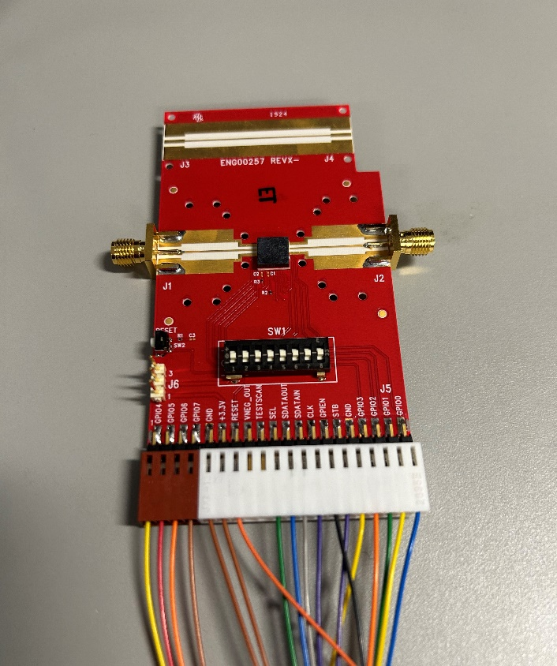

Figure 1. ENG00257.

# oPERATION

## Prior to turning on any voltages, ensure the following:

### GND is connected

### All dip switches are set to the MIDDLE position (floating),

### TEST_SCAN = 0V

### SEL = 0V

### Cable to the controller is connected correctly.

## Power-on Sequence (POS)

### $\overline{RESET}$**must** be 0V before turning on the +3.3V supply.

### +3.3V risetime must be greater than 100us.

### After 7.2.2, $\overline{RESET}$ must be set to +3.3V to begin device operation.



**Figure 2. POS Sequence timing diagram. Note that POR is internal to the device; it is neither an input nor an output.**

## GPIO/Parallel Mode

### TEST_SCAN must be 0V for proper internal supply operation in all modes.

### Perform POS in section 7.1

### To enable GPIO communications, set GPIOEN = +3.3V.

### There are 8 separate GPIO pins, labelled GPIO0 – GPIO7. By individually driving these GPIO lines with 0V or +3.3V, one can achieve full 8-bit tuning.

## Serial Mode

### TEST_SCAN, SEL must be 0V for proper operation.

### Perform POS in section 7.1

### To enable serial communications, set GPIOEN = 0V.

### Follow the timing diagram in Figure 3 and parameters in Table 5 to apply the serial tune command. Note that two rising edges of $\overline{STB}$ are required to finish a tune. This is to enable pre-loading of serial tune data for faster system level tune time.



Figure 3. Serial Control Timing Diagram.

|  |  |  |  |  |  |  |
| --- | --- | --- | --- | --- | --- | --- |
| **#** | **Parameter** | **Symbol** | **Min** | **Typ** | **Max** | **Unit** |
| T1 | Select Setup – The amount of time that select needs to be valid and present before the falling edge of $\overline{STB}$. | TSEL_SETUP | 100 |  |  | ns |
| T2 | Strobe Setup – The amount of time that strobe needs to be valid and present before the rising edge of CLK. | T_setup | 20 |  |  | ns |
| T3 | Data Setup – The amount of time that data needs to be valid and present before the rising edge of CLK. | TSETUP | 10 |  |  | ns |
| T4 | Data Hold – The amount of time that data needs to be valid and present after the rising edge of CLK. | THOLD | 10 |  |  | ns |
| T5 | Clock Duty Cycle | TSCLK_DC | 48 | 50 | 52 | % |
| T6 | Clock Period | TSCLK_PERIOD | 31.25 |  | 100 | ns |
| T7 | New Tune Command Period – The minimum time between the last rising edge of $\overline{STB}$, completing the current tune event, to the next falling edge of $\overline{STB}$ indicating the next tune event. | TNEW_TUNE | 1 |  |  | us |
| T8 | Tune Time – The time between the second rising edge of $\overline{STB}$ and the point at which the RF response is at 90% amplitude. | TTUNE |  | 400 | 1000 | ns |
| T9 | High Time – the minimum time $\overline{STB}$ must be high prior to the next falling edge of $\overline{STB}$ which activates the previously loaded tune word. | TSTB_HIGH | 20 |  |  | ns |
| T10 | Low Time – the minimum time $\overline{STB}$ must be low to activate the previously loaded tune word. | TSTB_LOW | 20 |  |  | ns |
| T11 | Hold Time – The minimum amount of time required between the last falling edge of SCLK and rising edge of $\overline{STB}$ | TSTB_HOLD | 20 |  |  | ns |
| T12 | Select Hold – The minimum time that strobe must be high before changing the state of the SEL signal. | TSEL_HOLD | 50 |  |  | ns |

Table 5. Serial Control Timing Parameters.

# IFC Set Up

## Connecting the IFC Hardware

### IFC IO and Cables

#### IFC connections include: Power supply input, USB, & IFC IO to EEPROM board IO.

#### EEPROM board IO include: IFC IO to EEPROM board IO & EEPROM board to Filter IO.

### Plug in the IFC power cable, then plug in the USB cable from the computer to the IFC.

### Prior to connecting the IFC to the EEPROM board cable, verify the EEPROM to filter cable is connected as shown in Figure 4. Note the position of the orange and white connectors on the ENG00254. Make sure the labels on the connectors are facing down towards the GND plane.

### Verify that the dip switches are set to the MIDDLE (floating) position. NOT -, NOT +.

### If all is correct, connect the IFC to the EEPROM board cable.

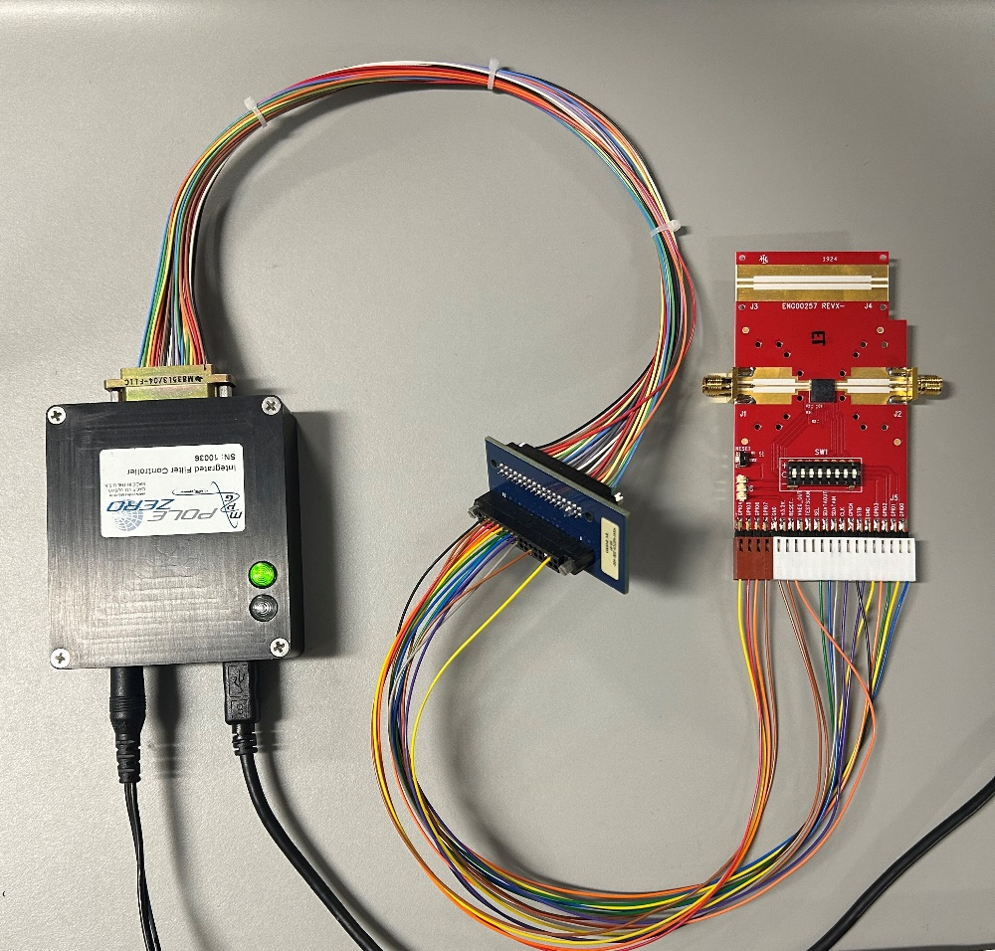

Figure 4. IFC Hardware setup.

## Controlling the filter using the IFC Software:

### Download & open 107417 Customer Demo Controller Software. (V1.3.0.0 or greater)

### Connect to the IFC: Under the Communication tab, Select “Auto” then “connect” in the dropdown menu under the communication tab to auto connect to the correct communication port.

### Set the Vcc and I/O voltages to +3.300V.

### IFC will automatically perform the POS as defined in section 7.1 when a state is turned on in the IFC software.

### Set all other parameters to desired values and apply ON state.

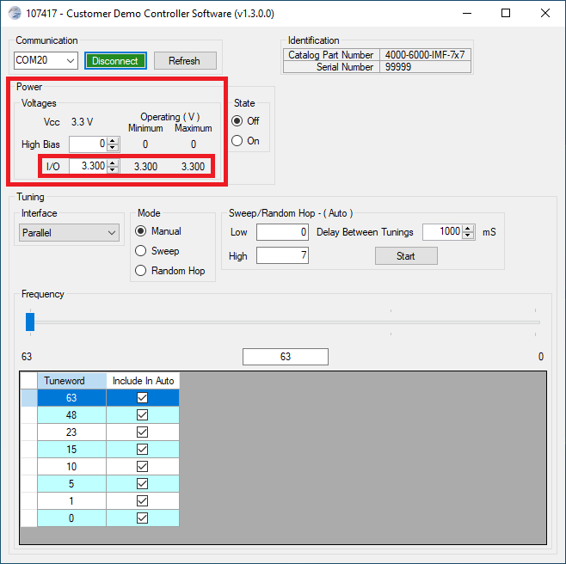

Figure 5. IFC Control Panel.

# Troubleshooting

## Red Light Reset

### If the red light on the IFC comes on as shown in the picture. The IFC will need to be reset.

### Reset the IFC by first unplugging the power chord and then the USB cable.

### Wait 1 minute and then plug them back in. Power suply first and then the USB cable.



Figure 6 - IFC Red Light